 JMCS | JOURNAL OF MEDIA AND COMMUNICATION STUDIES
Volume 2, Issue 2. July 2022

Effects of WhatsApp on Psychological Well-Being of Pakistani Youth

Nusrat Azeema , Dr. Bakht Rawan

Abstract
The study examined the various effects of WhatsApp usage on Pakistani youths’ (Hedonic and Eudaimonic) wellbeing. The survey included 300 participants, male and female of Islamabad with snowball sampling technique within the age bracket of 15-29 years, which belongs to different socio-economic status and age groups, formed the population of this research. The study found that more women than men use the WhatsApp platform. Participants who have better economic condition use more WhatsApp. Those who are older in age use more WhatsApp than others. The unique element of this study was that 51.7% of Islamabad’s youth feel stressed which triggers them to use WhatsApp for sharing their stress, depression, and feelings with others. Through the SWLS model, we concluded that Islamabad's Youth felt very happy and satisfied with their life and their physiological (Hedonic & Eudaimonic) well-being was affected by WhatsApp usage. Youth feels happy, satisfied, and socially connected by using WhatsApp.

Keywords: WhatsApp, Eudaimonic, Hedonic, Wellbeing, Youth, Happiness

Introduction
Nowadays, a significant progressive rate of WhatsApp usage is a substantial part of online communication (Blabst et al., 2017). WhatsApp is a mobile communication application initiated in 2009 by Jan Koum and Brian Acton (Olson, 2018) and developed by Igor Solomennikov (WhatsApp Revenue and Usage Statistics, 2019). According to WhatsApp 1 billion users are there in more than 180 countries. It mainly connects friends, family, and relatives through text, picture sharing, and video calling features. It is an application, which broadens the social circle within their different interest groups. Over time, they felt a need for a document-sharing feature, which enhanced its importance among students and the business community.
WhatsApp is an application that ensures end-to-end encryption and is a reliable platform. Recently, the WhatsApp usage rate in Pakistan has shifted upward dramatically while the positive and negative impact of WhatsApp on its users has received attention from scholars gradually. A social network site is an edifice, which has made up of a single user with a societal group. According to numerous past studies (Clement, 2019), results show that social networks have restricted one's location, societal background, or ethnicity. Today, social networks like Facebook, Skype, Twitter, Viber, WeChat, WhatsApp, etc. have become far more diverse and active with extensive, inter-cucultural, and inter-general configurations (Burke, Marlow & Lento, 2010). Precisely, WhatsApp has been observed as a social network site that allows its users to admittance a prodigious agreement of information swiftly. The modest features make the sequencer more accessible to a variety of users of diverse ages and socioeconomic statuses. WhatsApp enables everyone to communicate who has a Smartphone, internet access, and application installed respectively. The total cost of using WhatsApp is quite cheaper, almost up to one dollar per year (Sayan, 2016).
A social network site has been observed as a positive forum that can influence the activities of individuals and the productivity of society collectively. The study shows that social network sites offer simple, low-cost ways to unify associates, organize meetings, spread information, and measure and record views (Houghton & N. Joinson, 2010). Social media usage inculcates many impersonal associations, and sometimes it results in friendship, love, commitments, and friendly bond too (Habib, Hossain, Ferdous & Bayezid, 2018).
Social Network Sites (SNS) are a masterful way for youths' social demonstrative and intellectual growth. Social Network Sites such as WhatsApp provide a facility for their users to spread information and share images and links with other users as well. It has noticeably been realized (Dey & Parabhoi, 2017) that SNS has indorsed to encourage social communications in a computer-generated milieu. Users change their identity to computer-generated atmospheres by posting private data and statistics, and sharing pictures and other stuff for their benefit. WhatsApp has become very famous over the last two years and got an increase of over 350 million users in 127 countries and also rated as the most downloaded application (Cohavi, A., 2013), while 31 billion messages are sent on average in a day (Tzuk, A, 2013). WhatsApp's new features allow creating a group and joining within its limitations (Bouhnik & Deshen, 2014). SNSs can be a useful platform for foreigners (Damian & Van Ingen, 2014), since they may help build up social ties in the destination country and help keep up relationships with individuals in the desired state. The above studies find that SNS use is related to more out-group links, but not to more in-group ties.
This investigation additionally demonstrates that SNS use is linked to more prominent quality social connections among refugees. Researchers also found no association between general passionate revelation and SNS utilization on fulfillment with social relations (Damian & Van Ingen, 2014). Binder and Sutcliffe found that migrants use social network sites as an alternative to maintaining and outspreading their friends' circle. Substitution of SNS use stays away from a portion of the issues related to large systems situated on one site; specifically, the administration of various social circles. Not exclusively does this methodology hold potential for expanded social capital, but it additionally gives a specific motivating force to transients looked with the test of keeping in contact with back home and dealing with another social condition. Results also depicted that substitutes of different Social Networking Sites may establish a compensatory policy that assists in overcoming less socializing representation of single SNS (Binder and Sutcliffe, 2014).
Research indicates that WhatsApp has a positive impact on electronic dialogue journaling for the betterment of vocabulary word choice and it gives positive social change to students' voice writing skills (Issa & Alsaleem, 2014). There is occasionally, a straight line among circumstances and logical results in human conduct.

Literature Review
This research constructs a history that prompts goals and rehashed cyclesing, behavior, knowledge acquisition, and skills. Moreover, the use of social media is influencing the well-being of the users (Dhira, Yossatorn, Kaur & Chen, 2018) which is the primary concern of this study.
The well-being of the persons was hypothesized by categorizing the requirements that simplify someone's personal growth, measured as his/her autonomy, mental and physical competence, and his/her relatedness with others (Ryan & Deci,). Like Subjective Wellbeing (SWB), it has also been hypothesized as a person’s personal happiness feelings which have been measured through a happiness scale. And this happiness was measured by someone's life satisfaction intensity, the existence of a constructive affectionate attitude, and the absence of undesirable moves (Andrews & Withey, 1976; Diener, 1984). Psychological well-being (PWB) includes "positive affect, optimism, life meaning and purpose, and life satisfaction" (Hernandez, R. et al., 2017).
The estimation of happiness has been coordinated by assessing apparatuses that survey life satisfaction, the objective of Positive Psychology is to fabricate the level of life satisfaction. What methodology has been added to manufacture happiness? What interventions are best for achieving this target? What lifestyles advance this change? These inquiries were from the start raised in an intervention plan subject to legitimate fulfillment. Regardless, this position began to be tended to by Seligman from the eventual outcomes of his assessment all through the essential decade of this century (Scorsolini-Comin, Fontaine, Koller & Santos, 2013).

WhatsApp as Social Media
Report says that worldwide 2 million users are on WhatsApp (Tankovska, 2021). The research defined social media as a mode of many digital platforms that allows you to communicate and interact socially and allows you to write, send and share messages, photos, videos, and music being a user of any platform on Web 2.0 (Iyoha, 2015). Those web-based facilities permit users to build a profile within a constrained structure, and there must be an autogenerated list of other operators with whom we make or share some connections (Boyd & Ellison, 2007). According to that definition, WhatsApp is a Social Media application, which gives a platform to make their account and access it through weblink and enables them to know who your viewers, readers are (N. Verishagen, 2018). We can increase our connections when we join a group. Online networking is changing the manners in which how data moves far and wide. Speed and straightforwardness of data have expanded (G. Meikle, 2016). The job of conventional and new media is changing, and long-range interpersonal communication devices are permitted to team up, so that has never observed (Al-Deen & Hendricks, 2012). A senior speaker in brain science at Edge Hill University Dr. Linda Kaye said that heaps of discussion about the case investing energy in internet-based life are awful for our prosperity. yet we've discovered it probably won't be as terrible as we might suspect, the additional time individuals spent on WhatsApp, the more this identified with them feeling near their loved ones and they saw these connections to be acceptable quality." (Kaye, L. K., Monk, R. L., Wall, H. J., Hamlin, I., & Qureshi, A. W., 2018).
Wellbeing is a concept familiar to anthropology, economics, phycology, sociology, and other social sciences. Researchers said that well-being is measured by finding the good and bad conditions of life or how satisfied they are with their lives. They also mentioned that the relation of a person with their happiness and economy defines well-being, which is different for everyone (L. Smith and M. Clay, 2010). In Human-Computer Interaction (HCI), previous studies have primarily focused on the impact of Social Networking Services (SNSs) like Facebook on wellbeing (Burke & Kraut, 2016). The researcher said that those who spent more time on Facebook is negatively associated with a mediated mood that the feeling of not doing anything meaningful (Sagioglou & Greitemeyer, 2014). Now, WhatsApp becomes a significant communication platform, which becomes a vital means to continue a relationship of life on earth (Blabst et al., 2017).
Naturally, it's a quality of instant messaging shapes new rules of social interaction and opens new ways of communication. This study explores the effects of WhatsApp from the side of psychological wellbeing (PW) which is linked with previous studies on the use of technology it's wellbeing with the perspective of Human-Computer Interaction (HCI) along with basic psychology theory. Wellbeing is now realized as consisting not only of economic prosperity but also that ensures physical, social, psychological wellbeing along with environmental protection and preservation (Dr Sinha, 2014).
Furthermore, the study shows that a decrease in well-being was described as using Facebook as a means of social comparison and not as a platform for interaction (Karapanos, Teixeira & Gouveia, 2015). It thus looks that associated with SNSs, WhatsApp must create a more communicative usage, whereby a focus on single chats or group chats, could play a crucial role. Specifically, one-to-one conversations should be far more communicative, whereas WhatsApp group chat might be backing up less communication (Sagioglou & Greitemeyer, 2014).
Researchers said that the practice of Last Seen in WhatsApp could increase social pressure (Pielot, Martin & Kwak, Haewoon & de Oliveira, Rodrigo & Oliver, Nuria, 2014). They also said that having indications about the last time someone was online, makes hopes to receive a reply more promptly. Moreover, these findings can be shifted to the influence of Reading Receipts (RR). In line with that, (Abdullahi & Lim, 2014) discovered that Last Seen (LS) and Read Receipts (RR) can encourage addicts of Checking Behavior (CB). The United Nations' new resolution (2012) is that the pillars of the new economic paradigm would be sustainability, wellbeing,, and happiness (Dr. Sinha, 2014).
The research discovered that the requirement for relatedness is a forecaster for the use of WhatsApp, while the need for self-esteem is associated with Facebook usage (Karapanos, Teixeira & Gouveia, 2015). Another important aspect is the need for belongingness. A requirement to belongingness basically and persistently inspires men, and due to that, a strong desire to precede and preserve lasting interpersonal communications. Human beings look for regular, effective constructive conversations within the framework of lasting, gentle associations (Baumeister & Leary, 1995).
The individuals who don't know about jazz, skiing, dear kinship, or functioning as a vet are clearly in a more terrible position to decide for those inside these exercises. Maybe a couple despite everything have our points of view stitched in by outrageous destitution, drudgery, or choking shows. Perhaps a couple is so involved in gathering the essential needs that they cannot deal with anything else. About us, all, including a large number of the least instructed have presented to a gigantic exhibit of prosperity merchandise. Some accomplished straightforwardly, others using the creative mind. They incorporate in addition to other things the accompanying: the affections of family life, kinship, sexual connections, different types of brotherhood; word-related merchandise—given the colossal multiplication of intriguing sorts of work since the eighteenth century; game and exercise; home consideration and nursery care; an enthusiasm for different creatures; travel at home and now regularly abroad. One of the reasons for training in a vote-based society is to prepare individuals for a thriving life. As a component of this point, they likewise become better able to make decisions about human prospering. They become better‐informed supporters of the national and worldwide discussion (White, 2007).

Social Media Effect on our Wellbeing
The research found that social media is a threat to young people's well-being (Tamang, 2019). Trolling and bullying are other negative aspects of social media. Other than addiction in young people, it also increases stress, suicidal idealization, and low self-esteem. Mood deterioration is another severe effect of social media on young people. Photoshop images on social media increase low self-esteem. They also conclude that there is a positive relationship between social media and the well-being of young people as it can reduce stress. They also find that less sleep and excessive usage of social media create mental illness. (O'Reilly, Dogra, Whiteman, Hughes, Eruyar & Reilly, 2018). Study shows that social media damage sleeps quality, which leads toward stress and less self-esteem. Researchers said that social media notifications' Alert and messages ring tone are the essential factors of the low quality of sleep. Fear of isolation and missing out gives your idea to be online and active, which disturbs young people's sleep. They also found that late-night social media user interrupts their sleep and digital screen exposure affect their skin, mind and eyes health (Woods and Scott, 2016). SNS can be a fantastic device to create and keep up social networks; they likewise enable unique access to the lives and accomplishments of others, producing a decent breeding ground for social evaluation. The posts of Facebook (FB) contact are not typically a good representation of their daily life, and are frequently instead, a highlight reel of their festivities and accomplishments (Gerson, Plagnol & J. Corr, 2016).

Hedonic Psychology
The researcher explains that in the hedonic account, which has later on extended to Subjective Well-Being (SWB). In that account, wellbeing has defined as the existence of positive affect or more pleasure and the less pain or absence of negative affect (Kahneman et al., 1999). It also represents that hedonic psychology as the study of "what makes experiences and life pleasant and unpleasant" (Blabst et al, 2017). By identifying well-being in terms of positive affect versus negative effectt, hedonic psychology stances for a clear-cut objective of the study, explicitly maximizing positive human impact called happiness. Therefore, this study full of facts, signs or evidence for, in what way persons estimate utilities, take full advantage of the reward and improve inputs linked with Pleasure vs Displeasure (Deci, 2001). The hedonic approach defines wellbeing as more happiness and less pain (Dr. Sinha, 2014).
A nation's advancement file re-evaluated as far as the amount it has had the option to teach human qualities among its residents and not by how much material extravagance a nation has (Scorsolini-Comin, Fontaine, Koller & Santos, 2013). In this way, the advancement structure of every society ought to incorporate impacts of body and mind and ought to be equipped for deciding physical, social, moral and mental prosperity alongside monetary parameters. Among Muslims, the Five Pillars of Islam plan to teach a happy, ethical quality in which philanthropy, tranquillity, individual inclination and the control of childishness are the most astounding and most versatile temperance (Dr Sinha, 2014).

Eudaimonic Approach
The Eudaimonic approach, which centers around significance and self-acknowledgment and characterizes prosperity regarding how much an individual is completely working. Specialists can theory a positive relationship between Eudaimonic prosperity and Facebook power (Gerson, Plagnol & J. Corr, 2016). Research reported the online technology benefits are as improved self-confidence, perceived social support, improved social capital, safe identity experimentation, and amplified occasion for self-disclosure (Best, Manktelow & Taylor, 2014). They also reported the harmful effects as the increased experience of harm, social segregation, sadness, and cyber-bullying. The research found that children of parents who walk them to school reported possessing more positive emotions like feeling happy than the ones who used motorized transportation. The concept of Eudaimonic underlines accomplishing prosperity through "the improvement of an individual's best possibilities and their application in the satisfaction of by and by expressive, self-concordant objectives (Waterman et al., 2010).
Burke and his fellow researcher (2010) found that the association between directed communication and social capital's bonding with greater feelings and also decreases loneliness, it is bridging between social capital with overall friend network size. They also concluded that those users who report a decrease in bridging and bonding of social capital and feel an increase in loneliness consume greater levels of content. Quality of life improves through Education which has central importance. A family’s economic status is raised by Education. According to the researcher, education improves the condition of life, lowers infant mortality, and advances educational achievement and the next generation's well-being. Thus, better-quality education clutches both national and individual well-being (Dr. Sinha, 2014). Ellison and colleagues found that Facebook active user students feel higher levels of association between social capital, and the eeffects are greater for students with lower self-esteem (Ellison, Steinfield & Lampe, 2007).
This study has been conducted to explore relations between WhatsApp and their Happiness level (Eudaimonic Well-Being), how they positively build their Relations with Others, and they establish their Growth (Hedonic (Subjective Well-Being). WhatsApp is one of the most straightforward usable applications in the world and Pakistan now. The quantitative method of research has been used to get the findings of the study.
Stress Factor: The present study is about the effects of WhatsApp on the Psychological well-being of Pakistani youth. For that purpose, we asked about any stress factors, which our respondents faced before telling about their well-being. 51.7% said (Yes) they were exposed to some stress factors in the previous last week. 23.3% denied that they do not have any stress, and 25% are not sure about their stress condition. Univariate analyses have been conducted, and the results have been given in the following.

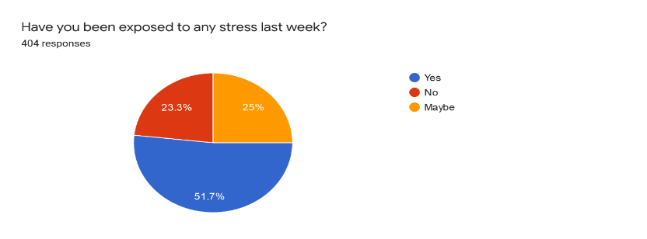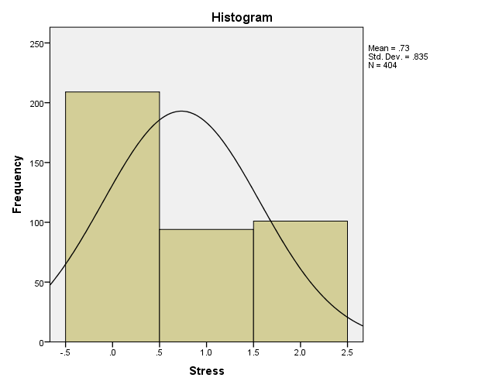

WhatsApp Users: The percentage of using WhatsApp features show that 37.4% of respondents use WhatsApp for texting. 7.7% of respondents use it for group chat. 2% use it for video chatting, 4.2% use this application for voice messaging, and 1.7% use it for document sharing. 27.5% of respondents said that they use the My status feature the most, 0.2% are using this application for location sharing, 2.0% use it for picture sharing purposes, and 17.3% said they handle all of the above features in WhatsApp. Univariate analyses have been conducted, and the results are given below.
Use A day
 |  | Frequency | Percent | Valid Percent | Cumulative Percent
Valid | Less than 2 hours | 92 | 22.8 | 22.8 | 22.8
Valid | 2 hours to 4 hours | 90 | 22.3 | 22.3 | 45.0
Valid | More than 4 hours | 222 | 55.0 | 55.0 | 100.0
Valid | Total | 404 | 100.0 | 100.0

The above table shows how much time respondents spend on WhatsApp in a day. So, 22.8% of respondents report that they use to spend less than 2 hours a day on WhatsApp, and 22.3% use it for more than 2 hours but less than 4 hours a day. However, the highest percentage of the respondents is that 55% use WhatsApp for more than 4 hours a day.
Satisfaction with Life Scale model
Through the SWLS model, we evaluated a person's quality of life, and we conclude the subjective well-being. In section 4, the life satisfaction model (Diener, E., Emmons, R. A., Larsen, R. J., & Griffin, S, 1985) has been analyzed. Univariate analyses have been conducted for the SWLS model, and the results are given in the following. The scale assesses a global level of life satisfaction, and is not only focused on specific domains of an individual's life, according to the subjective principles that the person has recognized for himself/herself.
Scale Statistics
Mean | Variance | Std. Deviation | N of Items | Reliability Statistics
10.62 | 22.717 | 4.766 | 5 | Cronbach's Alpha | Cronbach's Alpha Based on Standardized Items | N of Items
 |  |  |  | .909 | .915 | 5

This scale contains 5 items, each item is answered on a 5-points Likert scale (1 = strongly, 2 = Strongly Agree, 3 = Neutral, 4 = Dis-Agree, and 5 = Strongly Dis-Agree). The mean value of SWLS is 10.62. The variance is 22.717, and the standard deviation is 4.766, α value shows that the inter-correlation of these 5 items is 0.909, which indicates that the scale is internally reliable (Galanakis et al., 2017).
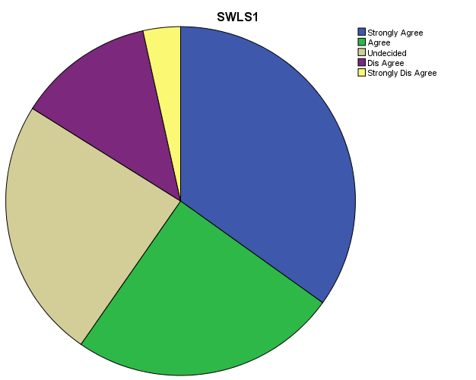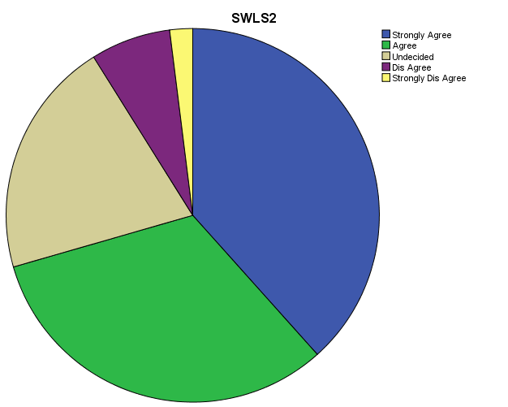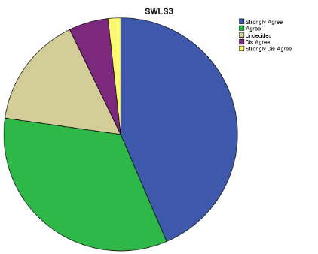
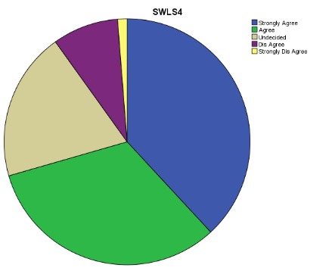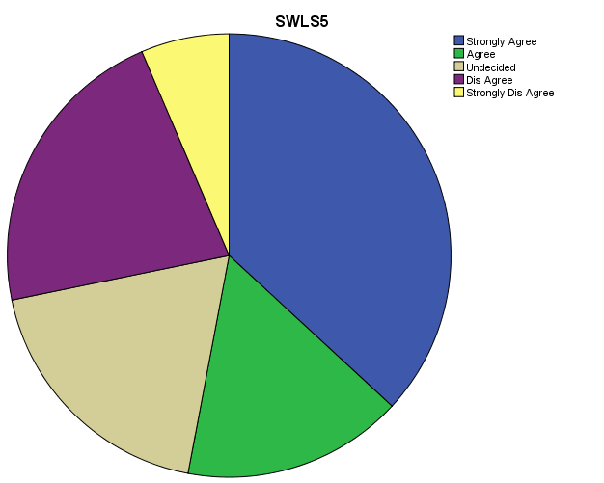

In the SWLS model, when we questioned about most ways that my life is close to my ideals, 33.8% of respondents agree with that, but 3.7% disagree with that. When we ask about their life condition is excellent, then 38.1% strongly agree with their life condition, but 2% strongly disagreed with this. In response to the question, I am satisfied with my life, 43.5% Strongly agree, and 1% strongly disagree with this statement. The answer under the question of So far, I have gotten the important things I want in life, 37.9% strongly agree with this, 36.9% strongly agree with the problem that If I could live my life over, I would change almost nothing.
Scale of Intensity (SI) of WhatsApp Use
The scale of intensity of WhatsApp used is to measure WhatsApp use beyond simple proportions of frequency and period, joining emotional connectedness to the social site and its integration into people's day-by-day activities (Ellison, Steinfield & Lampe, 2007). This WhatsApp intensity scale (SI) contains 5 items, each item is answered on a 5 - Likert scale (1 = strongly, 2 = Strongly Agree, 3 = Neutral, 4 = Dis-Agree, and 5 = Strongly Dis-Agree). The mean value of the WhatsApp intensity Scale (SI) is 8.17. The variance is 6.976, and the standard deviation is 2.641; α value shows that the inter-correlation of these 5 items, which is 0.337, which indicate that the scale is internally reliable.
Core-OM (Subjective Wellbeing): The Clinical Outcomes in Routine Evaluation – Outcome Measure has used to measure Wellbeing, Risk, Functioning and problems, and symptoms daily activities. This Core-OM contains 34 items, from which we take 4 items for evaluation. Subjective well-being each question is answered on a 5 - Likert scale (0 = Not at all, 1 = Only Occasionally, 2 = Sometimes, 3 = Often, 4 = Most or all the time). The mean value of Core-OM (Subjective Wellbeing) is 10.31. The variance is 18.223, and the standard deviation is 4.269; α value shows that the inter-correlation of these 4 items, which is 0.778, indicates that the scale is internally reliable. In regard of the question (I have felt alone and isolated) 32.4% respondent replied that Most or all the time, 33.9% felt tense, anxious or nervous most or all the time, 39.1% felt I have someone to turn to for support when needed, 52.5% felt OK about their self.
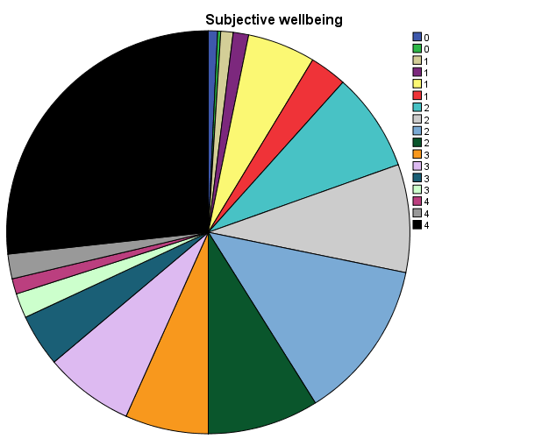

Overall, in 4 – item scale the most or all the time happening is respondents' Wellbeing which is 26.7%, after that 12.9% of respondents are Functioning properly and they have support when they needed.
H1: WhatsApp is positively associated with Psychological (Hedonic & Eudaimonic) wellbeing.

Correlations
 |  | SI | Psychological Wellbeing
SI | Pearson Correlation | 1 | .430**
SI | Sig. (2-tailed) |  | .000
Psychological Wellbeing | Pearson Correlation | .430** | 1
Psychological Wellbeing | Sig. (2-tailed) | .000
**. Correlation is significant at the 0.01 level (2-tailed).
b. Listwise N=904

Sig, which is less than 0.05, indicates that they have a significant relationship with each other. There is enough evidence to suggest that the correlational observed does exist in the population. Pearson Correlation of Scale of the intensity of WhatsApp uses and Psychological (Hedonic & Eudaimonic) wellbeing = 0.43.
P - Value = 0.000 ≤ 0.05

H2: It is more likely that psychological (Hedonic & Eudaimonic) wellbeing among users of WhatsApp having different age, income level and gender will have different level of psychological (Hedonic & Eudaimonic) wellbeing.
According to data 63.5%, youth with the age of 26 years and more but less than 30 are heavy WhatsApp users, and 15% are those who belong to 15 years and more but less than 20 years are less WhatsApp user.
Correlations
 |  | Age | Use A day
Age | Pearson Correlation | 1 | .207**
Age | Sig. (2-tailed) |  | .000
Age | N | 904 | 904
Use A day | Pearson Correlation | .207** | 1
Use A day | Sig. (2-tailed) | .000
Use A day | N | 904 | 904
**. Correlation is significant at the 0.01 level (2-tailed).
P≤ 0.05, the test is significant, so we said that there is significant relationship between hour of A day which spend on WhatsApp and age of youth. Among the three selected segments of users of WhatsApp, the highest age group segment uses this application the most. in other words, the majority of WhatsApp users belong to the highest age group segment of the selected. We found that females who use more than 4 hours a day WhatsApp has better Psychological Wellbeing than male. From 26 years to 30 years, youth who use more WhatsApp has high Psychological Wellbeing condition than others. That participant who get more than 16 years of education and use WhatsApp more than others has better Psychological Wellbeing. In addition, those who have more than 50k income and use WhatsApp more than others have high Psychological Wellbeing condition.
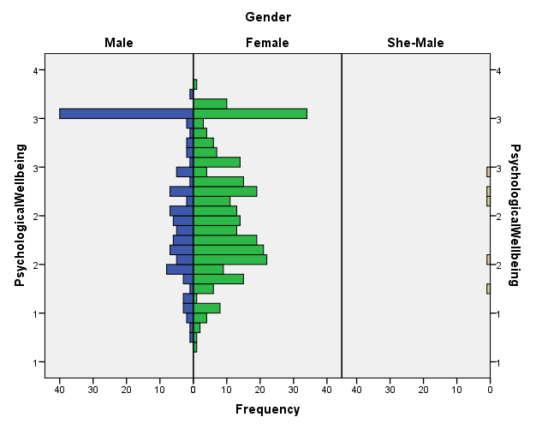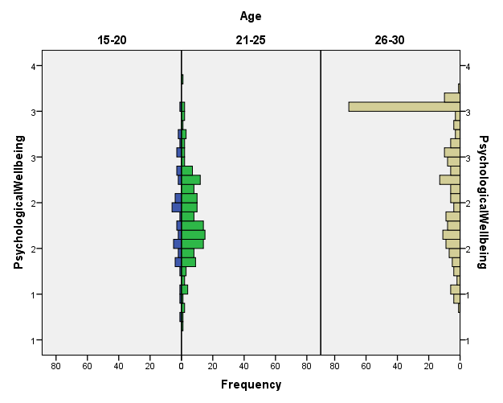

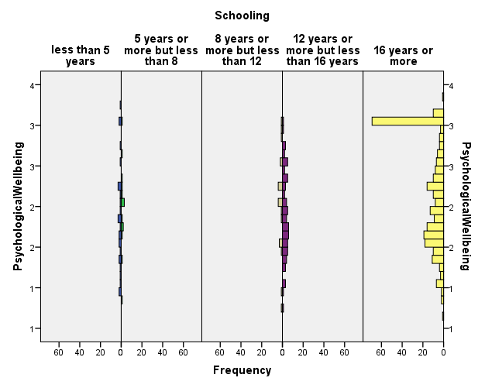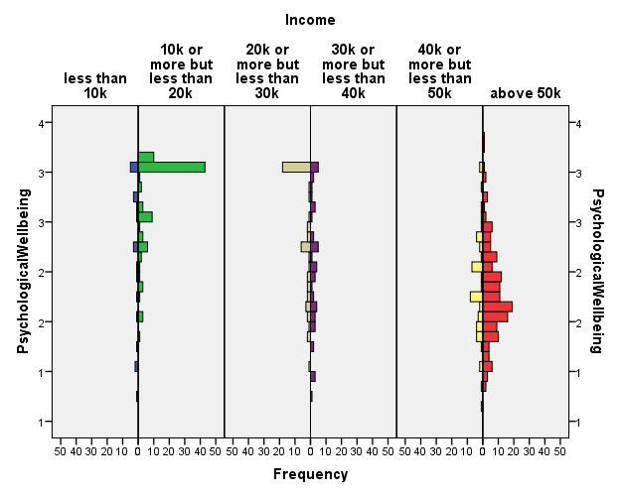

H3: Positive Relations with Others and Personal Growth (Eudaimonic Wellbeing) are quite closely associated with WhatsApp users.
As we analyze that the more, we use WhatsApp, we approach our Eudaimonic Wellbeing (Positive Relations with Others and Personal Growth). The more we become heavy WhatsApp users, the more we avail Eudaimonic Wellbeing (Positive Relations with Others and Personal Growth) state of mind. It also analyses that the user of WhatsApp have a positive relationship with others they say hello/hi for knowing other life condition and become positive in their life relation. It also analyses that WhatsApp user focuses on his/her personal growth by sharing their achievements and success through WhatsApp My Status.

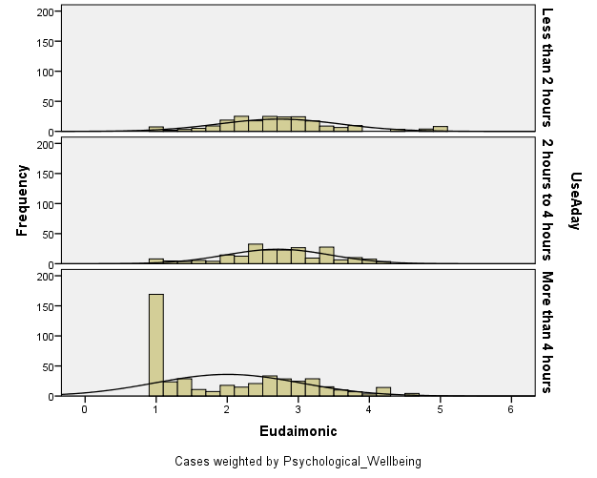

P≤ 0.05, the test is significant, so we said that there is a significant relationship between Eudaimonic Wellbeing (Positive Relations with Others and Personal Growth) and hour of a day, which spends on WhatsApp.
Correlations
 |  | Use A day | Eudaimonic
Use A day | Pearson Correlation | 1 | -.332**
Use A day | Sig. (2-tailed) |  | .000
Use A day | N | 904 | 904
Eudaimonic | Pearson Correlation | -.332** | 1
Eudaimonic | Sig. (2-tailed) | .000
Eudaimonic | N | 904 | 904
**. Correlation is significant at the 0.01 level (2-tailed).

The correlation coefficient between Eudaimonic wellbeing and Use of WhatsApp shows -0.332 is a weak (H. Akoglu, 2018) relationship between Use of WhatsApp in a day and its Eudaimonic effects. But negative sign shows that if one variable is increasing the other one is decreasing with same intensity (M. Henn, M. Weinstein & N. Foard, 2009) because the value of (p < 0.05).
H4: Heavy WhatsApp users are quite closely associated with Psychological (Hedonic & Eudaimonic) wellbeing.
As we found that WhatsApp has positive Psychological (Hedonic & Eudaimonic) wellbeing effects on their users. WhatsApp's impact on users' positive relationships with others is positive. It also directly affects users' personal growth and Happiness level. People use WhatsApp to share their time with their friends, family, and teachers. People use WhatsApp to share new experiences through My Status video or writing feature. They feel happy or satisfied after share their life happening through WhatsApp.
Correlations
 |  |  | Psychological Wellbeing | SI
Kendall's tau_b | Psychological Wellbeing | Correlation Coefficient | 1.000 | .380**
Kendall's tau_b | Psychological Wellbeing | Sig. (2-tailed) | . | .000
Kendall's tau_b | Psychological Wellbeing | N | 935 | 935
Kendall's tau_b | SI | Correlation Coefficient | .380** | 1.000
Kendall's tau_b | SI | Sig. (2-tailed) | .000 | .
Kendall's tau_b | SI | N | 935 | 935
**. Correlation is significant at the 0.01 level (2-tailed).

P≤ 0.05, the test is significant, so we said that there is a significant relationship between Psychological (Hedonic & Eudaimonic) Wellbeing and WhatsApp user time. 51.2% of people are heavy users who use WhatsApp more than 4 hours and have a positive relation with Psychological (Hedonic & Eudaimonic) wellbeing.
The correlation coefficient between Psychological (Hedonic & Eudaimonic) wellbeing and Use of WhatsApp shows τb = 0.380 is a weak (H. Akoglu, 2018) relationship between Use of WhatsApp in a day and its Psychological effects. But positive sign shows that if one variable is increasing, the other one is also growing with the same intensity (M. Henn, M. Weinstein & N. Foard, 2009) because of the value of (p < 0.05). Respondents are agreed that they use WhatsApp and feel happiness, life satisfaction, and personal growth.
H5: The use of WhatsApp is associated with a user’s Happiness (Hedonic Wellbeing).
We found that those who are heavy WhatsApp users are also have high Hedonic wellbeing. 51.2 % are those who spend more than 4 hours on WhatsApp and have high happiness level.
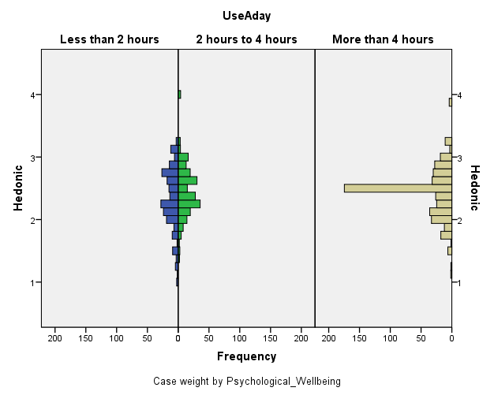
P≤ 0.05, the test is significant, so we said that there is significant relationship between Eudaimonic Wellbeing (Happiness) and have more than 4-hours of a day on WhatsApp.
Correlations
 |  | Use A day | Hedonic
Use A day | Pearson Correlation | 1 | .096**
Use A day | Sig. (2-tailed) |  | .004
Use A day | N | 904 | 904
Hedonic | Pearson Correlation | .096** | 1
Hedonic | Sig. (2-tailed) | .004
Hedonic | N | 904 | 904
**. Correlation is significant at the 0.01 level (2-tailed).
Among the two selected segments of Hedonic Wellbeing of WhatsApp users, the heavy users of WhatsApp have high Hedonic Wellbeing, in other words, the majority of WhatsApp users who use more than 4 hours have good Hedonic Wellbeing.

Conclusion
This research explored and examined the effects of WhatsApp on the psychological well-being of Pakistani youth. This study aimed to find out the difference between factors of WhatsApp usage and the consequential differences associated with these factors. This research also examined and explored the connection between the nature of WhatsApp users (like high WhatsApp users and light WhatsApp users) and demographic variables (like age, income, and gender).
The gathered data were analyzed on three levels i.e., univariate, bivariate, and multivariate, respectively, using multiple techniques of information analysis. For the univariate investigation, the researcher used some frequency tables, pie charts, bar charts, boxplots, stem, and leaf displays.
The univariate analysis of the use of WhatsApp showed that Text, Group Chat, Video Chat, Voice Message, Document Sharing, My Status, Location Sharing, Picture Sharing, and Audio Sharing were the most "frequent uses" made by WhatsApp users. These were followed by WhatsApp use for different purposes like "For relaxation," "For chatting," "To relieve boredom by calling others," "To kill time," "To delay something that I should be doing," and "To get away from something that I should be doing" and "To prevent unwanted personal interactions."
As far as the researcher is concerned about WhatsApp's associated needs, the univariate investigation verified that on the side of the different instrumental needs. the highest percentage of the youth in Islamabad were using WhatsApp for 'social connectedness,' 'co-ordination' and 'education and learning but has less percentage for 'information-seeking.' The researcher also concludes that in the ritualized needs category, the highest percentage of the youth tend to use WhatsApp for 'Fashion/Status.' Female WhatsApp user is higher than male; they earn '50k or more and have more than 16 years of education. In this study, we found that the youth of Islamabad is stressed, and the reason behind this might be the COVID 19 pandemic, which is increasing stress levels in youth. The unique factor is that 23.3% of the youth of Islamabad don't know about their mental health they replied 'maybe.'
According to previous research, Facebook's prominent feature allows its users to regulate what and how they want to present themselves in the online milieu. It has been found that many F.B. users practice image management and try to submit an idealized form of themselves by posting flattering images and showcasing status updates about their successes (Hui Chua & Chang, 2016). Like that, we observe in our study that WhatsApp users use "My Status" to build their image, portray their idealized version in the form of pleasing pictures, and update their daily progress.
Researchers also found that Facebook users have been allowed to gain an understanding of their Facebook friends' lives, which they would normally not have, thus making this SNS the ideal platform for social comparison (DeAndrea & Walther, 2011). Social comparison is the process by which individuals compare themselves to others. to obtain an external guideline against which they assess their opinions, skills, abilities, personality traits, aand emotions. Like that, we observe that WhatsApp allows users to see others' "My Status" and compare themselves with other people's progress and achievements, which they achieve in their lives.
We found that the youth of Islamabad are heavy users. They use this application for more than 4 hours. So, we conclude that this lockdown and pandemic situation helped the youth to decrease their stress through WhatsApp by sharing their ideas, videos, music, and group chatting. They update their status for updating their friends and family.
A study found that Facebook's newsfeed feature provides a continuous online stream of information about someone's lives, achievements, abilities, current happenings, emotions, and personality dimensions. It also creates a perfect imaginary home ground for doing different social comparisons (Bekalu, McCloud & Viswanath, 2019). Researchers investigate depressive symptoms by focusing on social comparison on Facebook and correlate it with subjective wellbeing. Through the Scale of Intensity (S.I.) of WhatsApp Use, we found that more youth are on WhatsApp and spending more than 4 hours. In the SWLS model, we found the youth of Islamabad feel very content with their life, and they are agreed not to change anything in life. In the Core-OM model, we found that the youth's wellbeing is a prominent factor when we talk about WhatsApp usage. 52% said they felt OK about themselves. In the Hedonic Wellbeing perspective, we found that youth of Islamabad maintain positive relationships with others through WhatsApp and show connectedness and coordination with their friends, family, relatives, and teachers by sending messages, voice notes, documents, video chats, group discussions, etc. In terms of personal growth, we found that youth feel happier to show their progress in education, success in the job, and life achievements through 'WhatsApp Status' updates. And they also know about their friends, family, relatives, and teachers’ personal growth through their 'WhatsApp Status' updates.
On the other side, we found youths' Hedonic Wellbeing through WhatsApp usage. In this study, we found that youth feels happy to share their thoughts, sorrows, and pains through group chat, voice notes, and picture sharing. Happiness brings satisfaction in life; that's why we use Life Satisfaction Model to know the level of happiness. The majority of WhatsApp users who use more than 4 hours have good Hedonic Wellbeing. We found that the happiness model gets the highest score, with the Intensity of WhatsApp usage. We conclude that those young people of Islamabad who are WhatsApp users feel happy and satisfied with their lives, friends, family, and surroundings by sharing their feelings, achievements, and happenings.

References
Abdullahi & Lim. (2014). Convenience or Nuisance?: The ‘WhatsApp’ Dilemma. Social and Behavioral Sciences. Retrieved April 6, 2019, from https://www.researchgate.net/publication/275544659_Convenience_or_Nuisance_The_'WhatsApp'_Dilemma
Arnold, Turner, Barling, Kelloway & McKee. (2017). Transformational Leadership and Psychological Well-Being: The Mediating Role of Meaningful Work. Journal of Occupational Health Psychology, 12(3), 193–203. Retrieved 06 20, 2019, from https://sci-hub.tw/10.1037/1076-8998.12.3.193
Baumeister & Leary. (1995). The Need to Belong: Desire for Interpersonal Attachments as a Fundamental Human Motivation. Psychological bulletin, 117. Retrieved April 6, 2019, from https://www.researchgate.net/publication/15420847_The_Need_to_Belong_Desire_for_Interpersonal_Attachments_as_a_Fundamental_Human_Motivation
Bekalu, McCloud & Viswanath. (2019). Association of Social Media Use With Social Well-Being, Positive Mental Health, and Self-Rated Health: Disentangling Routine Use From Emotional Connection to Use . Health Education & Behavior.
Best, Manktelow & Taylor. (2014, june). Online communication, social media and adolescent wellbeing: A systematic narrative review. Children and Youth Services Review, 41, 27-36. Retrieved 05 24, 2019, from https://www.sciencedirect.com/science/article/pii/S0190740914000693
Bhatt & Dr. Arshad. (2016). Impact of WhatsApp on youth: A Sociological Study. IRA-International Journal of Management & Social Sciences, 4(2). Retrieved Nov 2, 2019, from https://pdfs.semanticscholar.org/a282/03a5bc41060cc28b1acbe177b8dee0a7c7f8.pdf
Binder and Sutcliffe. (2014). The Best of Both Worlds? Online Ties and the Alternating Use of Social Network Sites in the Context of Migration. Societies, 753–769.
Blabst et al. (2017). WhatsApp and Wellbeing: A study on WhatsApp usage, communication quality and stress. British HCI: BCS Learning and Development. Retrieved April 6, 2019
Bouhnik & Deshen. (2014). WhatsApp Goes to School: Mobile Instant Messaging. Journal of Information Technology Education: Research, 3. Retrieved April 3, 2019, from http://www.jite.org/documents/Vol13/JITEv13ResearchP217-231Bouhnik0601.pdf
Boyd & Ellison. (2007, Oct 1). Social Network Sites: Definition, History, and Scholarship. Journal of Computer-Mediated Communication, 13(1). Retrieved Jun 10, 2019, from https://academic.oup.com/jcmc/article/13/1/210/4583062
Brown, E. (2011, June 30). content. Retrieved 5 15, 2019, from SocialMediaToday: https://www.socialmediatoday.com/content/strong-and-weak-ties-why-your-weak-ties-matter
Bryman, A., & Cramer, D. (2009). Quantitative data analysis with SPSS 14, 15 & 16: A guide for social scientists. Routledge/Taylor & Francis Group.
Burke & Kraut. (2016). The Relationship Between Facebook Use and Well-Being Depends on Communication Type and Tie Strength. Journal of Computer-Mediated Communication, 21(4). Retrieved April 6, 2019, from https://academic.oup.com/jcmc/article/21/4/265/4161784
Burke, Marlow & Lento. (2010). Social Network Activity and Social Well-Being. SIGCHI Conference on Human Factors in Computing Systems (pp. 1909-1912). New York, NY, USA: ACM New York, NY, USA ©2010. Retrieved 05 24, 2019, from https://dl.acm.org/citation.cfm?id=1753613
C. Michalos. (2007). Education, Happiness and Wellbeing. Is happiness measurable and what do those measures mean for public policy? University of Rome .
CivicScience. (2018). Heavy Social Media Users vs. General Population. Retrieved 06 20, 2019, from https://civicscience.com/
Clement, J. (2019). Most famous social network sites worldwide as of July 2019, ranked by number of active users. Statista. Retrieved from https://www.statista.com/statistics/272014/global-social-networks-ranked-by-number-of-users/
Cohavi, A. (2013). How did Watsap become the strongest social network of all? Calcalist. Retrieved April 3, 2019, from https://www.calcalist.co.il/local/articles/0,7340,L-3593840,00.html
Costanza, R., Fisher, B., Ali, S., Beer, C., Bond, L., Boumans, R., … Snapp, R. (2007). Quality of life: An approach integrating opportunities, human needs, and subjective well-being. ECOLOGICAL ECONOMICS, 61, 267 – 276. Retrieved 05 25, 2019, from https://sci-hub.tw/10.1016/j.ecolecon.2006.02.023
Damian & Van Ingen. (2014). Social Network Site Usage and Personal Relations of Migrants. Societies, 640–653.
DC DeAndrea & JB Walther. (2011). Attributions for inconsistencies between online and offline self-presentations. Communication Research.
Deci, R. &. (2001). ON HAPPINESS AND HUMAN POTENTIALS: A Review of Research on Hedonic and Eudaimonic Well-Being. Annu. Rev. Psychol, 52. Retrieved April 6, 2019, from https://psych415.class.uic.edu/Readings/Ryan,%20Happiness%20-%20well%20being,%20AnnRevPsy,%202001.pdf
Dey & Parabhoi. (2017). Use of Social Networking Site WhatsApp among the user of State Library, Shimla: a Case Study. Conference: 1St International Conference On Transforming Library .
Dhira, Yossatorn, Kaur & Chen. (2018). Online social media fatigue and psychological wellbeing—A study of. International Journal of Information Management, 141-152. Retrieved 15 5, 2019, from http://isiarticles.com/bundles/Article/pre/pdf/115030.pdf
Diehl, E. (2018, Sep 10). Who are Heavy Social Media Users? . Retrieved from civicscience.com: https://civicscience.com/who-are-heavy-social-media-users/
Diener, E., Emmons, R. A., Larsen, R. J., & Griffin, S. (1985). SATISFACTION WITH LIFE SCALE. Journal of Personality Assessment. Retrieved June 23, 2019, from https://fetzer.org/sites/default/files/images/stories/pdf/selfmeasures/SATISFACTION-SatisfactionWithLife.pdf
Diener, E., Suh, E. M., Lucas, R. E., & Smith, H. L. (1999). Subjective Weil-Being: Three Decades of Progress. Psychological Bulletin, 125(2), 276-302. Retrieved 05 25, 2019, from https://sci-hub.tw/10.1037/0033-2909.125.2.276
Diener, Oishi & Lucas. (2009). Subjective Well-Being: The Science of Happiness and Life Satisfaction (2ND ed.). (S. J. Snyder, Ed.) Retrieved 05 25, 2019, from https://www.oxfordhandbooks.com/view/10.1093/oxfordhb/9780195187243.001.0001/oxfordhb-9780195187243-e-017
Dovey, V. (2018, July 31). The Evolution of Messaging. Retrieved Oct 15, 2019, from dotdigital: https://blog.dotdigital.com/the-evolution-of-messaging/
Dr. Sinha. (2014). Happiness, Wellbeing, Gross National Happiness and Sustainability Education. EUROPEAN ACADEMIC RESEARCH, 2(7). Retrieved Aug 15, 2019, from https://www.academia.edu/9184511/Happiness_Wellbeing_Gross_National_Happiness_and_Sustainability_Education
E. Ruggiero. (2000). Uses and Gratifications Theory in the 21st Century. MASS COMMUNICATION & SOCIETY, 3-37.
Ellison, Steinfield & Lampe. (2007, August 23). The Benefits of Facebook “Friends:” Social Capital and College Students’ Use of Online Social Network Sites. Journal of Computer-Mediated Communication. Retrieved 05 24, 2019, from https://onlinelibrary.wiley.com/doi/epdf/10.1111/j.1083-6101.2007.00367.x
Gable, S. L., Reis, H. T., Impett, E. A., & Asher, E. R. (2004). What Do You Do When Things Go Right? The Intrapersonal and Interpersonal Benefits of Sharing Positive Events. Journal of Personality and Social Psychology, 87(2), 228–245. Retrieved 05 25, 2019, from https://sci-hub.tw/10.1037/0022-3514.87.2.228
Galanakis et.al. (2017). Reliability and Validity of the Satisfaction with Life Scale (SWLS) in a Greek Sample. THE INTERNATIONAL JOURNAL OF HUMANITIES & SOCIAL STUDIES.
Gerson, Plagnol & J. Corr. (2016). Subjective well-being and Social media use: Do personality traits moderate the impact of social comparison on Facebook? Computers in Human Behavior .
Granovetter, M. S. (1973). The Strength of Weak Ties. American Journal of Sociology. Retrieved May 9, 2019, from https://www.jstor.org/stable/2776392?seq=1#page_scan_tab_contents
H. Akoglu. (2018). User's guide to correlation coefficients. Turk J Emerg Med, 91-93. Retrieved from https://www.ncbi.nlm.nih.gov/pmc/articles/PMC6107969/
Habib, Hossain, Ferdous & Bayezid. (2018, May 21). Social Networks and Social Ties: Changing Trends among Urban Dwellers in Bangladesh. Open Access Library Inc, 5(5). Retrieved April 3, 2019, from http://file.scirp.org/Html/84655_84655.htm
Haller. (1954). A correlation analysis of the relationship between status and personality. University of Wisconsin--Madison. Retrieved June 25, 2019, from https://books.google.com.pk/books?id=aaUMAQAAMAAJ&q=correlation+analysis&dq=correlation+analysis&hl=en&sa=X&ved=0ahUKEwiViuPBz4TjAhUJcZoKHVr7CysQ6AEISjAG
Hernandez, R. et. al. (2017, Oct 20). Psychological Well-Being and Physical Health: Associations, Mechanisms, and Future Directions. Emotion Review, 10(1). Retrieved 5 15, 2019, from https://journals.sagepub.com/doi/full/10.1177/1754073917697824
Houghton & N.Joinson. (2010). Privacy, Social Network Sites, and Social Relations. Journal of Technology in Human Services.
Hui Chua & Chang. (2016). Follow me and like my beautiful selfies: Singapore teenage girls' engagement in self-presentation and peer comparison on social media. Computers in Human Behavior.
Intercom. (n.d.). The History of Messaging. The History of Messaging. Retrieved Oct 15, 2019, from https://www.intercom.com/history-of-messaging?page=page#firstPage
Issa & Alsaleem. (2014). The Effect of "WhatsApp" Electronic Dialogue Journaling on Improving Writing Vocabulary Word Choice and Voice of EFL Undergraduate Saudi Students. 21st Century Academic Forum Conference Proceeding. Harvard. Retrieved Aug 2, 2019, from http://www.21caf.org/uploads/1/3/5/2/13527682/alsaleem-hrd-conference_proceedings.pdf
Iyoha, B. E. (2015, Oct 25). YES, WHATSAPP IS A SOCIAL MEDIA PLATFORM (demystifying the stereotype). Retrieved from https://www.linkedin.com/pulse/difference-between-social-networking-media-whatsapp-ben-ehimen-iyoha
J. Andjelic. (2019). WhatsApp Statistics: Revenue, Usage, and History. fortunly. Retrieved 12 25, 2019, from https://fortunly.com/statistics/whatsapp-statistics#gref
Kahneman et al. (1999). Well-Being: The Foundations of Hedonic Psychology. Russell Sage Foundation. Retrieved April 7, 2019, from https://www.researchgate.net/publication/235361446_Well-Being_The_Foundations_of_Hedonic_Psychology
Kalpidou, M., Costin, D., & Morris, J. (2011). The Relationship Between Facebook and the Well-Being of Undergraduate College Students. CYBERPSYCHOLOGY, BEHAVIOR, AND SOCIAL NETWORKING, 14(4). doi:10.1089/cyber.2010.0061
Karapanos, Teixeira & Gouveia. (2015, Oct 15). Need fulfillment and experiences on social media: A case on Facebook and WhatsApp. Computers in Human Behavior. Retrieved April 6, 2019, from https://pdfs.semanticscholar.org/bf56/3082ea7dccb5b041696f4ba21b121b8f9d5b.pdf
Kaye, L. K., Monk, R. L., Wall, H. J., Hamlin, I., & Qureshi, A. W. . (2018). The effect of flow and context on in-vivo positive mood in digital gaming. International Journal of Human-Computer Studies, 45-52.
Kim, H. H. . (2019). Status perception, residential context and subjective wellbeing among South Korean adults: A multilevel analysis of primary survey data. The Social Science Journal, 13.
Kothari, C. R. (2004). Research Methodology: Methods and Techniques. New Age International.
Koum, J. (2017, Feb 20). WhatsApp-Status. Retrieved May 9, 2019, from https://blog.whatsapp.com: https://blog.whatsapp.com/10000630/WhatsApp-Status
L. Nabi, Prestin & So. (2013, oct 22). Facebook Friends with (Health) Benefits? Exploring Social Network Site Use and Perceptions of Social Support, Stress, and Well-Being. Cyberpsychology, Behavior, and Social Networking, 16(10). Retrieved from https://www.liebertpub.com/doi/abs/10.1089/cyber.2012.0521
L. Smith and M. Clay. (2010). Measuring Subjective and Objective Well-being: Analyses from Five Marine Commercial Fisheries. Society for Applied Anthropology, 69(2), 158-168. Retrieved Sep 1, 2019, from https://www.jstor.org/stable/44148599?seq=1#page_scan_tab_contents
Lee, G., Lee, J., & Kwon, S. (2011). Use of Social-Networking Sites and Subjective Well-Being: A Study in South Korea. CYBERPSYCHOLOGY, BEHAVIOR, AND SOCIAL NETWORKING, 14(3). Retrieved 05 25, 2019, from https://www.liebertpub.com/doi/abs/10.1089/cyber.2009.0382
M. Henn, M. Weinstein & N. Foard. (2009). A Critical Introduction to Social Research. SAGE.
M.Rubin & Windahl. (1986). The uses and dependency model of mass communication. Critical Studies in Mass Communication, 184-199.
Mathers M, Canterford L, Olds T, Hesketh K, Ridley K, Wake M. (2009). Electronic media use and adolescent health and well-being: cross-sectional community study. Academic Pediatrics, 307-314. doi:10.1016/j.acap.2009.04.003
Mondi, Woods and Rafi. (2008). A ‘Uses and Gratification Expectancy Model’ to predict students' ‘Perceived e-Learning Experience’. Educational Technology & Society, 241-261.
O’Reilly, Dogra, Whiteman, Hughes, Eruyar & Reilly. (2018). Is social media bad for mental health and wellbeing? Exploring the perspectives of adolescents. Clinical Child Psychology and Psychiatry.
Olson, P. (2018). Exclusive: WhatsApp Cofounder Brian Acton Gives The Inside Story On #DeleteFacebook And Why He Left $850 Million Behind. Forbes. Retrieved April 3, 2019, from https://www.forbes.com/sites/civicnation/2018/04/20/meet-some-of-the-2018-usow-summit-scholarship-recipients/#332128b75f3d
Pielot, Martin & Kwak, Haewoon & de Oliveira, Rodrigo & Oliver, Nuria. (2014). Didn’t You See My Message? Predicting Attentiveness to Mobile Instant Messages. Human Factors in Computing Systems. ACM SIGCHI. Retrieved April 6, 2019, from https://www.researchgate.net/publication/260567710_Didn't_You_See_My_Message_Predicting_Attentiveness_to_Mobile_Instant_Messages
Potharla, S. (2017, Dec 26). Retrieved from ResearchGate: https://www.researchgate.net/post/p_value_of_0000
Pryke, L. (2016). Hedonic or Eudaimonic Happiness. Retrieved from klusster: https://www.klusster.com/klussters/happiness-dialogue/publications/hedonic-or-eudaimonic-happiness-139
PTA. (2010). Annual Report 2009-10 . Islamabad: Pakistan Telecommunication Authority.
PTA. (2011). Telecom Quarterly Review. Islamabad: Pakistan Telecom Authority.
Punjab Youth Policy. (2012). Definition of Youth. Retrieved from PAKISTAN: https://www.youthpolicy.org/factsheets/country/pakistan/ , https://www.youthpolicy.org/wp-content/uploads/library/Pakistan_Punjab_2012_Youth_Policy_eng.pdf
Roffey, S. (2012). Developing Positive Relationships in Schools. In S. Roffey, Positive Relationships: Evidence Based Practice across the World (pp. 145-162). London: Springer.
Rudolf J. Freund, William J. Wilson, Ping Sa. (2006). Regression Analysis (2 ed.). Elsevier, 2006. Retrieved June 25, 2019, from https://books.google.com.pk/books?id=Us4YE8lJVYMC&dq=regression+analysis&source=gbs_navlinks_s
Sagioglou & Greitemeyer. (2014, June). Facebook’s emotional consequences: Why Facebook causes a decrease in mood and why people still use it. Computers in Human Behavior, 35. Retrieved April 6, 2019, from https://www.sciencedirect.com/science/article/pii/S0747563214001241
Sahir. (2019). WhatsApp Usage, Revenue, Market Share and other Statistics (2019). Digital Information World. Retrieved from https://www.digitalinformationworld.com/2019/02/whatsapp-facts-stats.html
Sankalp Raj Choudhary, Mohmmed Irfan H. Momin, S. L. Kantharia. (2017, April 27). Facebook and Whatsapp: Beneficial or Harmful? Journal of Evidence based Medicine and Healthcare, 2(17). Retrieved June 29, 2019, from https://www.jebmh.com/data_pdf/06%20-%20Sumana%20-%202.pdf
Satici & Uysal. (2015). Well-being and problematic Facebook use. Computers in Human Behavior, 185-190.
Sayan, H. (2016). AFFECTING HIGHER STUDENTS LEARNING ACTIVITY BY USING WHATSAPP. European Journal of Research and Reflection in Educational Sciences, 4(3). Retrieved June 29, 2019, from http://www.idpublications.org/wp-content/uploads/2016/02/AFFECTING-HIGHER-STUDENTS-LEARNING-ACTIVITY-BY-USING-WHATSAPP-Full-Paper.pdf
Scorsolini-Comin, Fontaine, Koller & Santos. (2013). From authentic happiness to well-being: the flourishing of Positive Psychology. PSYCHOLOGICAL ASSSESSMENT. Retrieved from http://www.scielo.br/scielo.php?pid=S0102-79722013000400006&script=sci_arttext&tlng=pt
statista. (2019). most-popular-global-mobile-messenger-apps/. Retrieved from https://www.statista.com: https://www.statista.com/statistics/258749/most-popular-global-mobile-messenger-apps/
statista. (2019). Social Media & User-Generated Content. Retrieved May 9, 2019, from statista: https://www.statista.com/statistics/278414/number-of-worldwide-social-network-users/
Stone, S., & Logan, A. . (2018). Exploring Students’ Use of the Social Networking Site WhatsApp to foster connectedness in the online learning experience. Irish Journal of Technology Enhanced Learning, 44-57.
Surendran, A. (2019). QUANTITATIVE RESEARCH: DEFINITION, METHODS, TYPES AND EXAMPLES. QuestionPro. Retrieved Sep 9, 2019, from https://www.questionpro.com/blog/quantitative-research/
Tamang, A. (2019, April 5). The impact of Social Media on our mental wellbeing : Technological blessing with a dark side. The impact of Social Media on our mental wellbeing : Technological blessing with a dark side. Thrive Global. Retrieved Sep 7, 2019, from https://thriveglobal.com/stories/the-impact-of-social-media-on-our-mental-wellbeing/
Toker, S. &. (2012). Social Network Citizenship. In S. &. Toker, Handbook of Research on Business Social Networking: Organizational, Managerial, and Technological Dimensions (pp. 339-357). doi:10.4018/978-1-61350-168-9.ch017
Trochim, Donnelly & Arora. (2015). Research Methods: The Essential Knowledge Base. Cengage Learning.
Tromholt, M. (2016). The Facebook Experiment: Quitting Facebook Leads to Higher Levels of Well-Being. CYBERPSYCHOLOGY, BEHAVIOR, AND SOCIAL NETWORKING, 19(11). Retrieved Sep 21, 2019, from https://sci-hub.tw/10.1089/cyber.2016.0259
Tzuk, A. (2013). Wattsap reached 350 million active users a month. Calcalist. Retrieved April 3, 2019, from https://www.calcalist.co.il/internet/articles/0,7340,L-3615097,00.html
UNDP . (2018, May 3). Pakistan currently has largest youth population of its history: UNDP report. Retrieved from THE NEWS INTERNATIONAL: https://www.thenews.com.pk/print/311910-pakistan-currently-has-largest-youth-population-of-its-history-undp-report
University of Southern California. (2019, Aug 28). Organizing Your Social Sciences Research Paper: Quantitative Methods. Organizing Your Social Sciences Research Paper: Quantitative Methods. CALIFORNIA. Retrieved Sep 8, 2019, from https://libguides.usc.edu/writingguide/quantitative
Valkenburg, P. M., Peter, J., & Schouten, A. P. (2006). Friend Networking Sites and Their Relationship to. CYBERPSYCHOLOGY & BEHAVIOR, 9(5). Retrieved 05 25, 2019, from https://www.liebertpub.com/doi/abs/10.1089/cpb.2006.9.584
Van Laar. (2014, July 7). Smartphone usage in Pakistan. Retrieved Nov 1, 2019, from https://grappetite.com/blog/smartphone-usage-in-pakistan/
Vanhoutte & Nazroo. (2014). Cognitive, Affective and Eudemonic Well-Being in Later Life: Measurement Equivalence over Gender and Life Stage. Sociological Research Online.
Vanhoutte, B. (2012). Measuring subjective well-being in later life: a review. CCSR Manchester. Retrieved June 21, 2019, from http://hummedia.manchester.ac.uk/institutes/cmist/archive-publications/working-papers/2012/2012-06-Briefing%20wellbeing%20Bram%20Vanhoutte_final.pdf
Waterman et al. (2010). The Questionnaire for Eudaimonic Well-Being: Psychometric properties, demographic comparisons, and evidence of validity. The Journal of Positive Psychology, 41-61.
Wen, Geng & Ye. (2016). Does the Use of WeChat Lead to Subjective Well-Being?: The Effect of Use Intensity and Motivations. CYBERPSYCHOLOGY,BEHAVIOR, AND SOCIAL NETWORKING, 19(10). Retrieved June 23, 2019, from https://www.ncbi.nlm.nih.gov/pubmed/27732075
West & H. Turner. (n.d.). Introducing Communication Theory ANALYSIS AND APPLICATION (4 ed.). McGraw-Hill. Retrieved Oct 27, 2019, from https://www.academia.edu/36356550/Introduction_of_Communication_Theory_West_and_Turner_
WhatsApp Revenue and Usage Statistics. (2019, Feb 19). Retrieved from Bussiness of Apps: https://www.businessofapps.com/data/whatsapp-statistics/
White, J. (2007). Wellbeing and Education: Issues of Culture and Authority. The Philosophy of Education Society of Great Britain. Retrieved Aug 15, 2019, from https://onlinelibrary.wiley.com/doi/abs/10.1111/j.1467-9752.2007.00540.x
Woods and Scott. (2016, june 20). #Sleepyteens: social media use in adolescence is associated with poor sleep quality, anxiety, depression and low self-esteem. Journal of Adolescence, 41-49. Retrieved Sep 7, 2019, from http://eprints.gla.ac.uk/120206/7/120206.pdf

M.Phil scholar, Department of Mass Communication, AIOU, Islamabad
Associate Professor, Department of Mass Communication, AIOU, Islamabad

