 JMCS | JOURNAL OF MEDIA AND COMMUNICATION STUDIES
Volume 2, Issue 2. July 2022

Infusion of Technology for Education during COVID: Lessons Learnt for Skills and Strategies

Faiza Khalid

Abstract
The world is evolving rapidly; digitalization is the core of this era. Every field needs to adapt to changes the world at large is going through to keep up with the technological pace. During the outbreak of COVID-19, throughout the world, the traditional set-up of education was in pause. So, the use of digital technology was the only solution to restart the education system. The focus changed from the traditional setup to online education. The schools’ framework has been changed and upgraded with the infusion of technology. Initially, there had been chaos and turmoil in the school management as the instructors and the students were facing lack of information. The major focus of this paper is to examine the role of technology in education in the educational year 2020-2021. This study will be used as a platform to review the strategies that are used by the educationists of the 21st century. It will also help teachers, learners, and the general public to understand the survey of technology in education. Survey research is used as a method to review and analyze the data.

Keywords: Traditional education, Online education, COVID-19, Technology.

Introduction
Everything was messed up, life became lifeless; there were no plans or agenda but then everything redesigned. The world restructured and reformed by the global pandemic, and the need of education, at that time, just like many other foundations and institutions, stepped into a new chapter and confluence. It was the outburst of this contagious disease that each and every system got digitalized and this synchronization brought to the book the fault lines of olden times. COVID-19 exposed the realities of ongoing systems, procedures, and setups, especially in educational institutions. Education is a basic pillar of society, as a better society and environment is attained only through a worthy educational system. Education in any form (Formal, Non-Formal, Religious, etc.) is very important and has the value of a core for the existence of human beings. Traditional education has its pros and cons. While referring to the traditional setup, it is a classroom with everything present in real time and space including; physical attendance, infrastructure, etc. The environment is without a doubt ideal and improves the mental and physical development of a child. While being a part of a regular system, students get a lot of time to interact, play, communicate and eat together as a unit. During the pandemic, society faced the worst phase of life; where access to resources, places, and entertainment was diminished for both the Haves and the Haves Not. The crisis affected everyone equally on all grounds (Sharma, 2021).
Being a part of a regular system, helps children in building their community skills along with seeking education. It also fosters in them better discipline, mental attentiveness, and physical fitness. The current century is the age of technology and just like everything getting technologized, the traditional education systems are flipped and technology has taken the lead in the classrooms as well. Traditional education facilitates practical learning, hand on knowledge and firsthand experience for all learners. All the mandatory apparatus or material is also provided in the traditional setup for learning (Qureshi, Ilyas, Yasmin & Whitty, 2012). Technology is used for assistance and a better understanding of concepts. This century has revived the scenarios of education and technology, from being an assistant to practical education has been switched as a core factor and very basic for the education in every school, college and university (Khan, Javeria & Numan, 2014). When in 90s someone talked about the shifting paradigm: usage of the glossy digital books, that will contain tetra byte and even data, people would hardly believe it (Kirkwood & Price, 2005). There is a rapid digitalization in the education sector, technology is getting infused in each and every school of the country (Ahmad, 2014). Although the process has been complex yet interesting, challenging yet flexible and innovative as well. These technological diffusions in the education has been a key point of this 21st century (Chandra, 2005). Previously, technology was only introduced to matriculation or secondary school education. Now, as the demands of the time are entirely different from previous times and centuries, computer education starts from the very basic level that is pre-school (Rehman & Khan, 2021). All the tech-friendly credits go to COVID-19, that educational scenario has altogether changed (Patrinos, 2021), whether it’s a government or private institute. Technology is used for assistance and a better understanding of the concepts (Baig, Yousaf, Aazam, Shamshad, Fida & Aslam, 2019).
Use of the technology in education has been a matter of interest since the start of 21st century. Most of the educational tools for online dissemination have been developed in this century. These tools and technologies have changed the scenario, and traditional setup is converted into more communal and info-tech-based systems (Fuentes, 2020). The learning environments and the setups have ruled out the restrictions of boundaries of geographies, as international standards of education can be achieved while sitting in one place. The current education system is an advanced and enhanced system of education, simpler, tech-friendly, and with advanced features. Technological infusions, in education, play a key role in facilitating and gaining knowledge experience, and self-directed learning. As technology is significantly available in various fields, it is now a question how much of technology should be infused in education at all levels.
This research is focused on 21st century learning techniques and technologies. How the advancement of technology is recreating the educational scenario? (Gujjar, 2013). The infusion of new technologies in education has redefined its realism. Both the teachers and students have to be well equipped for surviving this new educational scenario. The educational scenario in the current COVID state is very challenging (Sharjeel, Dool & Shah, 2020). The authorized educational bodies in Pakistan are creating technology based scenarios for enhancing the capabilities of educational institutes (Silverstone, Phadungtin & Buchanan, 2009). The growth in the telecommunication networks also give more advancement to mobile-based learning.
The research question formulated for this research were
- Have the technological infusion in educational scenarios improved the teaching standards and strategies?
- How does COVID-19 affect the technological scenarios in university education?
- What are the lessons learned through the technological infusion in the Pakistani educational setup?

Literature Review
Learning has always been a diverse experience, but for the children of 21st century it is complex as well. Because of the infusions of the modern technologies, the scenarios and the educational environments have been altogether changed (Iqbal & Campbell, 2011). The focus of today’s leadership and government is on addressing the needs and the challenges of the 21st century. The government has created an alliance of business leaders, educationists and government officials to combat these upcoming challenges (Farooq, Rathore & Mansoor, 2020). Together these think tanks have made an alliance on six core aspects for the improvement in education. First of all, it is to emphasize on the core subjects that are English, Urdu, Math, Science and General Knowledge. Secondly, emphasize on the learning skill, how we can inculcate in this generation to think and learn on their own. Third is to use the technology and the 21st century tools in education. Fourth is to teach and learn in the context of 21st century. Fifth is to upgrade the content in light of 21st century requirements. Sixth one is to use the 21st century measure of assessments.
In order to address the usage of technology in developing the learning skills there are three alternative opinions about them by Dede (2004). Single user desktop approach, multi user virtual environment and the ubiquitous computing (Weiser, 1999, Chapter 1). Ubiquitous computing relates to the third wave of computing, where the popular opinion says that the computers takes a back place (Leh, Kouba & Davis, 2005). A hand-held computing device is an example of this. According to the instructors there are many benefits of the hand held computers, first of all it is the improved quality of instructional activities in technical subjects specially, enhancements of collaboration and the communication. Improved organizational skills in the learners, improved motivation and a variety of autonomous learners. The affordability and the versatility of the hand held devices is another attractive feature. Along with availability of the handheld devices, there is a need to have great quantity of free educational soft wares that should be utilized by the students for reading, writing and drawing.
The educational scenarios have been changed in last few years (Luterbach & Brown, 2011). Student of today is so well equipped in the classroom, that he can have the recording of the lecture or the screenshots of the whiteboard for future referencing (Mumtaz, Saqulain & Mumtaz, 2021). If the student of today gets a computer connected to the internet than he can bring a lot of innovation in education. Technology based education is environment friendly too as there is less paper wastage and more practical form of concepts (Thaheem, Abidin, Mirza & Pathan, 2021). Online educational platforms give an interactive format to connect the students with the teacher. Through the use of technology in online education, boundaries of taking assistance from foreign teachers are diminishing (Hussain, Hussain & Ramzan, 2019).
Learning and educational scenarios have been through a lot of transitions in Pakistan. COVID-19 has revolutionized the educational setups (Vockley, 2007). Since the start of 2020, pandemic has engulfed the world & has adversely affected the all spheres of life and the education sector has been no exception. The pandemic forced the educational institutions to think differently and adopt measures to enable online education & learning using social media platforms & applications such as WhatsApp, Zoom, and Microsoft Teams etc. E learning & distance learning has been crucial in allowing education to resume and rolled out across Pakistan (Das, Khwaja & Malkani, 2021). Technologically evolved nations have modern and advanced systems for online learning, permitting them to stay within the loop and maintain the getting to know for the duration of the academic year. But in Pakistan, online education or online classes is at a beginning stage. It needs further focus to overcome the limitations. Faculty also want schooling to use online modalities and progressive pedagogies to reduce cognitive load and increase interactivity. This critical period, which is moving us hastily towards the adoption of online learning, can spark greater awareness on providing internet facilities in far-off regions, developing greater innovations, low-cost learning solutions, and creating more effective methods of learning in the future (Das, Khwaja, Malkani, 2021).

Research Methodology
The major focus of this study was to examine the technological infusions during COVID and the orientations, patterns, and trajectories that come out as a result. Later on, it focused on the strategies adopted by the educational institutes to cater to the challenges of COVID. Along with this, the study also inspected the characteristics and capabilities of digital technologies in educational settings, specifically in 2020-2021. The population of the study was the university students in Pakistan’s capital city, Islamabad. It has been also under consideration that the results received will help in upgrading the educational systems of the universities. The results will also help the teachers and the general public to understand the role of technology and education. This study will be used as a platform to enhance the skill development and the strategies that are used by the educationist of the 21st century. It will be helpful for teachers, learners, and the general public to understand the role of technology in education. The Survey research method was used in this research to receive and analyze the data.

Procedure
For the purpose of meeting the targets of the study, an online survey was used. A questionnaire consisting of 20 questions was created and distributed via google forms. The questionnaire had closed-ended questions based upon a Five-point Likert scale that ranged from strongly agree to strongly disagree. The participants consisted of 100 from students of different 4 universities in Islamabad. The age group of the students was between 18 years to 24 years. The questionnaire was filled from the students who had undertaken both, traditional and the educational system of education. The questionnaire consisted of questions ranging from educational scenarios, technological aspects, online examination, security issues, and lack of resource availability to mental health during online scenarios.

Findings
Technology and its role in this century are undeniable. Its presence is mandatory in each and every aspect of life. When Marshall McLuhan described the technological men, women, and children, his approach was back in 1951, it was very accurate to what we see today. He aptly predicted that technology will overpower all the natural processes and manpower (McLuhan, 1951). All the things and happenings in the whole wide world like delivery, growth, end and also education are technological dependent. The better technology is used or incorporated, better would be the knowledge outcome of the students. Technological infusion is necessary and needs time but on the other hand, the impacts of practical, in-person, and hand pieces of training are undeniable. The study found that there is a huge number of challenges, hurdles, and benefits related to technological infusions in educational scenarios. During COVID, willingly or unwillingly, the institutes had to adapt technology to their curriculum as the need of time. But the infusion of technology into an educational setup requires a lot of brainstorming, strategizing, implementing and adapting the skills, and transferring and revamping the curriculum by unbundling the course outlines and infusing the technology in them. The next step can be implementing the strategies and responding to all the challenges of technology to create a state of art technological environment. This innovation requires huge capital investment for its implementation and the cost can somewhat be reduced by appreciating and encouraging the students to bring their own technology to the university. Universities can also assist the managements to create technology based course content in a cost effective way. Universities may take online subscriptions from outside tech based universities and have virtual interactions with them and their technical staff/faculty can assist the students. Through the use of technology in education, students can have better access to resources in classrooms and can create better research-based content.
Where there are benefits attached to technology, there are a lot of obstacles involved too. There are chances that students rather than understanding the course content and exploring educational content get engaged in social interaction online and waste their time. Improper training on both sides; of teachers and of students, may lead to disastrous circumstances in society.
Following are the questions that were asked along with a graphical representation of the responses. This research aimed at exploring the challenges and opportunities during COVID-19 along with giving suggestions and learnings for future policymakers for digitalizing the educational content. The research is based upon the concept of technology infusion in education setups. Higher education is not only aimed at providing knowledge but also the skills and grooming for facing the challenges of the real world. Technology should get infused but the traditional teaching methodology should not be ignored and should be implemented in its true spirit. Technology alone is not a solution, physical interaction, learning by example and imitation in class is also an integral part of the educational setup. Technology should be used as an added facility to improve the standard of education not to replace the traditional concept of a classroom.
This qualitative study was carried out using a questionnaire based upon diversified questions regarding the pandemic and its implications for education. The results are graphical and represented in form of pie charts so that the readers can easily deduce the findings. The questions are based on 5 points Likert scale ranging from strongly agree to strongly disagree.
- Do you think having your own laptop, computer or tablet helps you in taking online education?
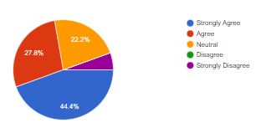
Figure: 1.1
The respondents which included university students have agreed to the phenomenon when asked that having your own laptop, computer or tablet helps you in taking online education. It was from the answers of the respondents that having you own gadget will help in getting better understanding and education through online systems. 20% were neutral about the phenomenon.
2. Are you well aware of the required software/application/technology?
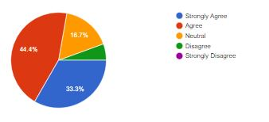
Figure: 2.1
When the respondents were asked about their awareness about the applications that were used during the COVID-19 for educational dissemination more than 70 % of the respondents agreed. It was clear that understanding of the software makes online education easier and better. 20% of the respondents were neutral about it.
3. Have you faced any connectivity issues during the online classes?
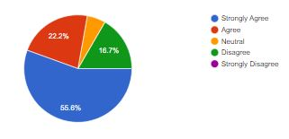
Figure: 3.1
The question that was about the connectivity issues faced during the online classes, 70% of the respondents faced problems in their internet connection and 20% were disagreeing to it.
4. Do you think there are high security associated when you are having online exams?
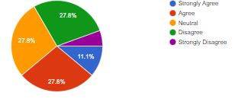
Figure: 4.1
When asked about the security concerns that respondents faced during the online examinations 40% of the respondents agreed to it 30% disagreed to it, and 30% marked it as neutral.
5. Do you think there is a huge difference between the quality of traditional and online setting?
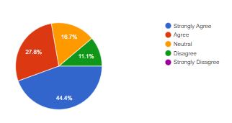
Figure: 5.1
When asked about the difference between the traditional and the formal settings when it comes to educational dissemination, 70% agreed to it. Rest of the ratio was disagreeing to it or neutral about the scenario.

6. Do you think that the instructors are being very inconsiderate to student’s circumstances during online education?
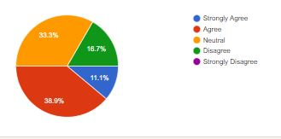
Figure: 6.1
When asked the respondents about circumstances of the educational setups and instructors understanding the problems faced by the students. 50% of the students said they faced the problems that their instructors never understood. 35% were neutral about the phenomenon.
7. Do you think there is a chance to get stress and mental health issues due to online learning?
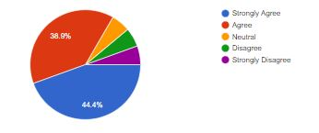
Figure: 7.1
When asked the question about the mental health issues that students faced during the COVID scenario more than 85% of the students agreed to it and rest of 15% were either neutral or disagreed to it.
8. Do you think that online learning experience is difficult than the formal setup?
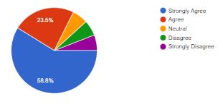
Figure: 8.1
When asked about the learning experiences that one has during the online setup is more difficult than the traditional setup. 80% of the students were agreeing to it and the rest of them were indifferent about the phenomenon.
9. Do you think that online education is inadequate for learning and it feels like you are teaching ourselves?
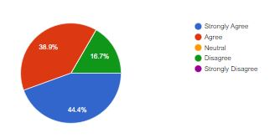
Figure: 9.1
When asked the respondents about the inadequacy of learning experience when it is online, 80% of the individuals marked it as inadequate and insufficient. Rest of them disagreed to it.
10. Do you think that during the online lecture there is little or no interaction with class mates?
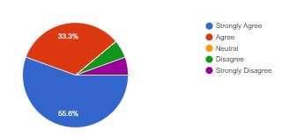
Figure 10.1
When students were asked about having interactions with the classmates during the online setup almost 90 % of them agreed that there is no interaction in an online setup. 10% disagreed to it.
11. Do you think that the Lack of labs and technical facilities affects the learning outcomes in online education?
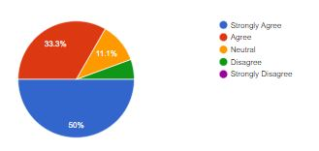
Figure: 11.1

When asked the students about the technical facilities that they had during the online educational setup almost 85% of the students agreed to it that they studied with lack of technical facilities or labs even when they were required to gain a healthy educational experience.
12. Do you think that the Lack of resources like books, art supplies/equipment for class affects the learning environment?
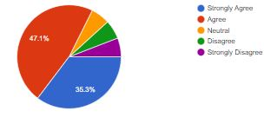
Figure 12.1
The learning experience online lacked the resources such as art supplies or handbooks that were required for the grasp on the educational setup lacked tremendously. 85% of the students agreed to it.
13. Do you think that the online Education is as effective as traditional system of the education?
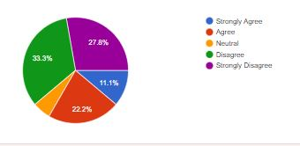
Figure 13.1
When asked about the effectiveness of the online education only 33% agreed to it and 60% of the student disagreed to it and said that traditional setup is more effective than the online setup. Rest of the respondents were indecisive about it.
14. Do you think all subjects that are being that in Pakistani syllabus can easily taught online?
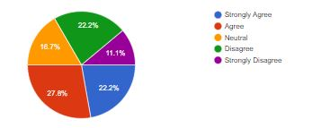
Figure: 14.1
When the respondents were asked about the question related to the Pakistani syllabus that subjects that are taught in Pakistan are easily taught online or not. 50% of the students agreed to it. 30% were disagreeing and 20% were neutral to the phenomenon.
15. Do you think while taking the education online, the students learns a lot about the different learning management systems?
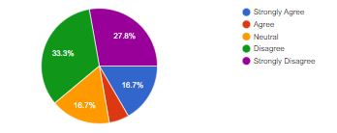
Figure: 15.1
When the respondents were asked about the understanding, learning management systems and its knowhow 20% agreed that they learned the systems as well. 60% disagreed to and they were of the opinion that they did not learned anything about the systems during the online education setups.
16. Do you think the standards of teaching in universities via online is very good?
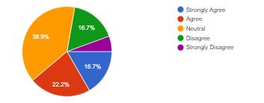
Figure: 16.1
When the respondents were asked about the learning setups and standards in universities in online systems, 30% agreed to it that setups are good 40% were neutral about the systems that their universities have good systems or not.
17. Do you think both student and teachers have constraints while having online education?
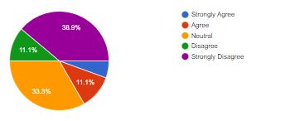
Figure: 17.1
When the respondents were asked about the constraints of online education for teachers and the students online 15% of the students thought that there are problems in online education 50% disagreed to it and 35% disagreed to it.

18. Do you think that COVID-19 has initiated the online education and made it a new normal?
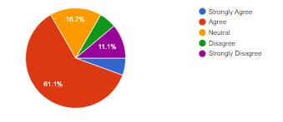
Figure: 18.1
When asked about the online setup during the COVID-19 scenario 65% of the respondents said that educational setups after COVID have changed and now it is a new normal. 15% disagreed to it 20% of them were neutral about the setup.

19. Do you think government should take serious measures in normalizing the online education?
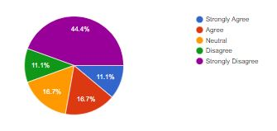
Figure: 19.1
When asked the respondents if the government should take adequate measures to normalize the online education 28% of the respondents only agreed to it and 55% were against it.
20. Do you think that online education should continue as it is?
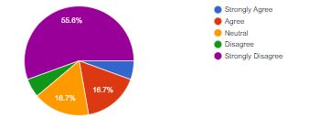
Figure: 20.1
When respondents were asked about the question that the scenario that started during COVID should continue as it is 60% of the individuals disagreed to it. Only 20% agreed to it and 20% were neutral about it.

Discussion and Analysis
This research analyzed an important aspect of the current era’s challenge which is the infusion of technology into the educational setups. A comprehensive questionnaire was created to understand the challenges, strategies, obstacles, and dilemmas that come in the path of this infusion. COVID-19 was a table turner, in every field of life, everything changed, including the dynamics of society and even of a home were changed too. The concept of education was revamped, upgraded and revolutionized. During COVID, willingly or unwillingly the institutes have to adapt the technology to their curriculum as the need of time. But the infusion of technology into an educational setup requires a lot of brainstorming, strategizing, implementing and adapting the skills, and transferring and revamping the curriculum by unbundling the course outlines and infusing the technology in them. Technological infusion is necessary and needs time but on the other hand, the impacts of practical, in-person, and hand pieces of training are undeniable. The study found that there is a huge number of challenges, hurdles, and benefits related to technological infusions in educational scenarios. This innovation requires huge capital investment for its implementation and cost can somewhat be reduced by appreciating and encouraging the students to bring their own technology to the university. Universities can also assist the managements to create the technology based course content in a cost effective way. Universities may take online subscriptions from outside tech based universities and have virtual interactions with them and their technical staff/faculty can assist your students. Through the use of technology in education students can have better access to resources in classrooms and can create better research-based content.
This research explored the challenges and opportunities during COVID-19 along with giving suggestions and learnings for future policymakers for digitalizing the educational content. Technology should get infused but the traditional teaching methodology should not be ignored and should be implemented in its true spirit. Technology alone is not a solution, physical interaction, learning by example and imitation in class is also an integral part of the educational setup. Technology should be used as an added facility to improve the standard of education not to replace the traditional concept of a classroom.
The research paper was based upon three major assumptions that were:
- The technological infusion in educational scenarios have improved the teaching standards and strategies
- If COVID-19 affected technological scenarios in university education or not
- Are there any lessons learned through the technological infusion in Pakistani educational setup?

It was concluded on the basis of these assumptions that due to the use of technology in educational setup, the standards of education are improved and students’ interest in subject enhances when technology is used along with the lecture method. For the second assumption it was concluded that because of COVID institutions all over Pakistan had to improve their standards of teaching and technology. The universities went online and they created their own Learning Management Systems to enhance the quality of education. The third assumptions have been concluded on following points:
- Having your own laptop, computer or tablet helps you in taking online education.
- Clear that understanding of the software makes the online education easier and better.
- The better the internet connection the better the understanding in an online setup.
- Online setup is not an ideal setup for examination.
- There is a significant difference between the traditional and the formal settings when it comes to educational dissemination, people find traditional setup better.
- There are few unseen problems that instructors never realized during an online setup.
- There are some mental health issues that students faced during the COVID scenario.
- The learning experiences that one has during the online setup is more difficult than the traditional setup.
- The learning experience when it is online being inadequate and insufficient for a comprehensive learning experience.
- In the online educational setup, students are unable to interact with their fellows just like the way they do in traditional setup.
- The technical facilities during the online educational setup almost lacked and there is an unavailability of labs required to understand concepts and on-hand trainings.
- The learning experience online lacked the resources such as art supplies or handbooks that were required for the grasp on the educational setup lacked tremendously.
- The Pakistani syllabus can be taught online with some modifications in their curriculum.
- The Online teaching management systems of the universities are difficult to understand and even though spending more than a year in online scenarios, students are still unable to understand it.
- There is a dire need to improve the learning setups and standards in universities in online systems to make online education a new normal.
- There are a lot of challenges and constraints in the online education for both teachers and students.
- The students have internalized the online systems as a part of their lifelong learning system.
- There is a requirement from the government to take adequate measures to normalize the online education and make it simpler to grasp.
- Although students are making their full efforts to understand the online setup but they find it more comfortable when things get back to the traditional scenario.
- Most of the student are not happy with the situation to continue for a longer period of time and they are only accepting it because they want to keep themselves COVID free.
- Since a country like Pakistan is a third world country, so in order to keep the things going normal there are a lot of efforts required to upgrade the technology and its understanding.

Conclusion
COVID-19 changed everything, whether it is people or a system, everything changed. There was a global lockdown, people were afraid to shake hands. Education systems suffered a lot, initially, all institutions were closed and they were in a dismal that how the systems are going to run. The only solution that was sorted was the use of technology. Online education was the only solution to disrupt the interception in the field. Curriculums were revised and technology got infused as it was the need of the time in around the world. Pakistani institutes also adopted certain systems to cater to the need of time. It was a new thing for most of the institutes and students as only a traditional setup was used previously. Later on, Technology became an integral part of every course and curriculum. Institutes developed their own reliable, secure and cost-effective system for their academia. Nowadays in every government and private institute, it is necessary to have a gadget for education.
Most people in Pakistan have traditional approaches and they were not satisfied with or in favor of the online education system. They are more comfortable with the traditional education system and find this convenient to them. Approaches of these traditional minds were also changed and they understood the importance of technology and its usage in education. In Pakistan, there were no proper pieces of training for teachers and students to use these systems as all of this happened suddenly. Teachers and students were not properly aware of how to use technology properly to teach or learn. But with the passage of time minds were changed and they adopted that technology should be used in education as it reinforces the concepts yet traditional education should not get ignored at all.
Along with many other challenges, in Pakistan teachers and students have to face connection and electricity problems too. The quality of the education gets affected, if the connection is slow or gets disrupted during an online class. Students and teachers both faced a lot of obstacles and problems in the online education system and that’s why they responded that they do not want to continue with a virtual system alone, education should be a blended mode if the technology has to be a part of it.
The level of satisfaction attached to online education is partial, students and teachers are satisfied because technology helped the in continuing their education during the pandemic but alone virtual education is not the solution of the problem. Education should be move back to the classroom along with technology infused in it.
Government should also take initiatives and actions to improve the infusion of technology and quality technology-based education. So that it can help us in crises when we are not able to go to colleges or universities and it is also helpful for students who want to study but are unable to go to educational institutes due to some problems. Teachers and students should be provided with the proper knowledge of technology so that it helps them in gaining education through technology when needed.
In this research the technological infusion in educational setup during COVID and its effects were examined. It focuses on how the institutions of higher education ought to be conscious of the needs of both today's and tomorrow's learners. The institutes need to adapt a wireless state, which depends on technology for normal obligations and brilliant achievements and vital affairs of education. Efforts are being taken to train teachers to improve methods of virtual teaching. HEC is also in touch with telecommunication groups to ensure internet connectivity and internet packages for students. Online education has become common in COVID era. The advent of 3G/4G/5G technology has contributed to the boom in mobile learning. Technology in education has been unexpectedly advancing; smartphones, laptops, high-speed internet, 4G, and 5G connectivity. All of this makes online learning productive, adaptive, and on hand. In today’s world, education through technology has a lot of importance and has advantages but in Pakistan, we also have to face many challenges.
Whether or not it is the educational field or other area, changes are required everywhere. The knowledge of technology is necessary for working or for getting knowledge in today’s era. Nowadays, everyone wants a virtual life. The online lessons can assist students to get education visually, and due to this, they are ready to remember things easily what they need learnt. Software and technology is changing very rapidly, and it is able to be tough to stay up with those developments. It's therefore important to learn strategies of online teaching. If we will make this digital initiative successful, we could have a threefold impact: enable children to keep learning at home, enable educational institutes to interact with their students and remain afloat, and permit teachers to continue their employment during this crisis.

References
Ahmad, I. (2014). Critical Analysis of the Problems of Education in Pakistan: Possible Solutions. International Journal of Evaluation and Research in Education, 3(2), 79-84.
Arif, S., Zia, T., Mustafa, G., Qayyum, Z., Ateeq, M., Faiz, M. J., ... & Ullah, I. (2022). Knowledge, Attitude and Practices of Medical Students Regarding Covid-19, Pakistan. Pakistan Journal of Medical & Health Sciences, 16(03), 783-783.
Baig, F. Z., Yousaf, W., Aazam, F., Shamshad, S., Fida, I., & Aslam, M. Z. (2019). Power, ideology and identity in Digital Literacy: a sociolinguistic study. International Journal of English Linguistics, 9(2), 252-264.
Chandra, R. (2005). Universal education and technology in 21st century (Vol. 10). Gyan Publishing House.
Das, J., Khan, A. Q., Khwaja, A. I., & Malkani, A. (2021). Preparing for crises: Lessons from COVID-19. LSE Public Policy Review, 1(4).
Digital Literacy in the 21st century Pakistan BY Chaudhry Faisal Mushtaq https://www.globalvillagespace.com/digital-literacy-in-the-21st-century-pakistan/
Educating Generation Z: Effects of Covid 19 BY Ujala Akram https://www.bsolpk.org/21st-century-education/educating-genz-covid19
Farooq, F., Rathore, F. A., & Mansoor, S. N. (2020). Challenges of online medical education in Pakistan during COVID-19 pandemic. J Coll Physicians Surg Pak, 30(6), 67-9.
Fuentes, G. (2020). The COVID-19 Pandemic Has Changed Education Forever. In World Economic Forum (April 2020).
Gajjar, N. B. (2013). The role of technology in 21st century education. Int J Res Educ 2, 23, 25.https://en.unesco.org/news/covid-19-10-recommendations-plan-distance-learning-solutions
Hussain, I., Hussain, I., & Ramzan, M. (2019). Future Prospects of Virtual Education in Pakistan: Opportunities and Challenges. Journal of Research in Social Sciences, 7(1), 149-163.
Iqbal, M. Z., & Campbell, A. (2021). Covid-19, education, and challenges for learning-technology adoption in Pakistan. Interactions, 29.
Kamran, K., & Ali, A. (2021). Challenges and strategies for Pakistan in the third wave of covid-19: A mini review. Frontiers in Public Health, 9.
Khan, F., Javeria, U., & Numan, M. (2014). Education, foreign direct investment and socio-economic development-A review. Abasyn Journal of Social Sciences, 7(2), 269-277.
Kirkwood, A., & Price, L. (2005). Learners and learning in the twenty‐first century: what do we know about students’ attitudes towards and experiences of information and communication technologies that will help us design courses? Studies in higher education, 30(3), 257-274.
Leh, A. S., Kouba, B., & Davis, D. (2005). Twenty‐first century learning: communities, interaction and ubiquitous computing. Educational Media International, 42(3), 237-250.
Luterbach, K. J., & Brown, C. (2011). Education for the 21st century. International journal of applied educational studies, 11(1).
McLuhan, H. M. (1951). The mechanical bride (p. 101). London: Routledge & Kegan Paul.
McLuhan, M., & Fiore, Q. (1967). The medium is the message. New York, 123(1), 126-128.
Mumtaz, N., Saqulain, G., & Mumtaz, N. (2021). Online academics in Pakistan: COVID-19 and beyond. Pakistan Journal of Medical Sciences, 37(1), 283.
Mumtaz, N., Saqulain, G., & Mumtaz, N. (2021). Online academics in Pakistan: COVID-19 and beyond. Pakistan Journal of Medical Sciences, 37(1), 283.
Nasar, A., Akram, M., Safdar, M. R., & Akbar, M. S. (2021). A qualitative assessment of entrepreneurship amidst COVID-19 pandemic in Pakistan. Asia Pacific Management Review.
Patrinos, H. A. (2021). The Learning Challenge in the Twenty-first Century. In Media, Technology and Education in a Post-Truth Society. Emerald Publishing Limited.
Qureshi, I. A., Ilyas, K., Yasmin, R., & Whitty, M. (2012). Challenges of implementing e-learning in a Pakistani university. Knowledge Management & E-Learning: An International Journal, 4(3), 310-324.
Rasheed, R., Rizwan, A., Javed, H., Sharif, F., & Zaidi, A. (2021). Socio-economic and environmental impacts of COVID-19 pandemic in Pakistan—an integrated analysis. Environmental Science and Pollution Research, 28(16), 19926-19943.
Rehman, A. U., & Khan, B. (2021). Challenges to online education in Pakistan during COVID-19 & the way forward. Social Science Learning Education Journal, 6(07), 503-512.
Sharjeel, M. Y., Dool, M. A., & Shah, S. T. A. (2020). Analysis of Pedagogic Concerns about Covid-19 in Educational Institutions in Pakistan.
Silverstone, S., Phadungtin, J., & Buchanan, J. (2009). Technologies to Support Effective Learning and Teaching in the 21st Century. In Advanced Technologies. IntechOpen.
Thaheem, S. K., Abidin, M. J. Z., Mirza, Q., & Pathan, H. U. (2021). Online teaching benefits and challenges during pandemic COVID-19: a comparative study of Pakistan and Indonesia. Asian Education and Development Studies.
Traditional education is not enough BY Rohail Anwar Khan https://archive.pakistantoday.com.pk/2011/11/28/traditional-education-is-not-enough/
Vockley, M. (2007). Maximizing the Impact: The Pivotal Role of Technology in a 21st Century Education System. Partnership for 21st Century Skills.

Lecturer, Mass Communication, National University of Modern Languages, Islamabad. Email: fkhalid@numl.edu.pk

